**SAVING LIVES, EYES AND VISION THROUGH EDUCATION.**

**THE BIG   
CHRISTMAS   
CHARITY QUIZ**

**THE QUIZ ROUNDS**

R.1 Touch wood

R.2 RED 0R WHITE

R.3 JUST A LETTER

R.4 FOOD STATUS

R.5 SCULPTURES

R.6 COLOURS

R.7 SPORT 2023

R.8 OLD BONES

R.9 RADIO AND T.V.

**2023**

* **WELCOME! PLEASE START BY CHOSING A TEAM NAME**
* **THE QUIZ COMPRISES 9 ROUNDS MAX 10 POINTS PER ROUND**
* **PLAY A JOKER ON ANY ONE ROUND (PRE MARKING!)**
* **AND DOUBLE YOUR POINTS. (BIG “J” TOP OF ANSWER PAPER PLEASE)**
* **MAX QUIZ SCORE = 100**
* **TEAMS COMPRISING MORE THAN 6 MAY NOT USE THE JOKER**
* **PLEASE NO CHEATING WITH SMART PHONES OR TABLETS ETC**
* **CONTESTANTS CAN APPLY FOR THE ANSWER SHEET ANYTIME   
    
  FROM BOXING DAY TO THE QUIZMASTER JOHN BIRD ON BJOHN365@AOL.COM**
* **PLEASE EMAIL YOUR SCORE BACK TO BJOHN365@AOL.COM.   
  A LEAGUE TABLE WILL BE PUBLISHED IN JANUARY**
* **THE WINNING ENTRY WILL RECEIVE A £25 AMAZON VOUCHER**

**GOOD LUCK, HAVE FUN AND THANK YOU FOR YOUR DONATION.**

Round 1. Decode the tree varieties

|  |  |  |  |  |
| --- | --- | --- | --- | --- |
| 1 |  |  | 6 |  |
| 2 |  |  | 7 |  |
| 3 |  |  | 8 |  |
| 4 |  |  | 9 |  |
| 5 |  |  | 10 |  |

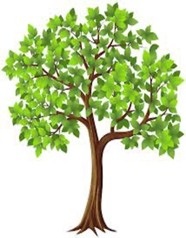

Round 2. Red and white varieties

|  |  |  |  |  |
| --- | --- | --- | --- | --- |
| 1 |  |  | 6 |  |
| 2 |  |  | 7 |  |
| 3 |  |  | 8 |  |
| 4 |  |  | 9 |  |
| 5 |  |  | 10 |  |

|  |  |
| --- | --- |
| 1. NAME THIS LIGHT RED FRENCH WINE (VIN DE PRIMEUR) MADE FROM THE GAMAY GRAPE AND USUALLY SOLD ON THE THIRD THURSDAY EVERY NOVEMBER |  |
| 1. WHAT IS THE SIX LETTERED TRADITIONAL TERM FOR A RED WINE FROM BORDEAUX |  |
| 1. NAME THIS TOWN IN FRANCE 14 MILES SOUTH OF RHEIMS THAT IS HOME TO MANY FAMOUS CHAMPAGNE HOUSES E.G. *MOET AND CHANDON, MUMM, POL ROGER AND MERCIER* |  |
| 1. THE NAME OF THIS GERMAN WHITE WINE MIGHT IMPLY THAT YOU ARE IN DEBT? |  |
| 1. A MAGNUM CONTAINS HOW MANY LITRES |  |
| 1. THE GRAND CRU RED WINE *ROMANEE-CONTI* IS MADE FROM WHICH GRAPE VARIETY |  |
| 1. NOW CELEBRATING ITS 71ST YEAR, IN WHICH VILLAGE WOULD YOU FIND THE OLDEST COMMERCIAL VINYARD IN ENGLAND FOUNDED BY MAJOR GENERAL SIR GUY SALISBURY-JONES |  |
| 1. MADE USING THE METHODE CHAMPENOISE THE SPARKLING WINE “CAVA” COMES FROM WHICH COUNTRY? |  |
| 1. A SQUAT BOTTLE, TRADITIONALLY PRESENTED IN A STRAW BASKET AND MADE WITH AT LEAST 80% SANGIOVESE GRAPES – NAME THIS WINE |  |
| 1. SPELT WITH 14 LETTERS AND MEANING HERB OR SPICE NAME THIS AROMATIC WHITE WINE WITH A STRONG BOUQUET OF LYCHEES – SAID TO GO WELL WITH A CURRY DISH! | - - - - - - - - - - - - - - |

Round 3. Just one letter

|  |  |  |  |  |
| --- | --- | --- | --- | --- |
| 1 |  |  | 6 |  |
| 2 |  |  | 7 |  |
| 3 |  |  | 8 |  |
| 4 |  |  | 9 |  |
| 5 |  |  | 10 |  |

|  |  |
| --- | --- |
| 1. What letter starts the most chemical element symbols in the periodic table? |  |
| 1. What is the most common blood type in the general population? |  |
| 1. Which letter is immediately to the right of the y on the top row of a keyboard? |  |
| 1. Which letter denotes loud on a sheet of music |  |
| 1. Which letter is the answer to the trick riddle. “It occurs once in a minute, twice in a moment, but never in a thousand years.”? |  |
| 1. Which letter denotes 50 in Roman Numerals |  |
| 1. This vitamin deficiency might cause rickets |  |
| 1. Which letter is denoted by three dashes in the International Morse Code? |  |
| 1. Which letter denotes a number that measures how quickly a virus is spreading in the population during a pandemic? |  |
| 1. Now, use your 9 letter answers to make a phrase that spells a weather pattern. | - - - - - - - - - |

Round 4. Give the *official full* names of these U.K. protected geographical status food names (e.g. CP = Cornish Pasty)

|  |  |  |  |  |
| --- | --- | --- | --- | --- |
| 1 |  |  | 6 |  |
| 2 |  |  | 7 |  |
| 3 |  |  | 8 |  |
| 4 |  |  | 9 |  |
| 5 |  |  | 10 |  |

|  |  |  |  |  |
| --- | --- | --- | --- | --- |
|  | MMPP |  |  | WL |
|  | SC |  |  | YFR |
|  | WO |  |  | JRP |
|  | IOMQ |  |  | DC |
|  | AS |  |  | CS |

Round 5. Sculptures and statues

|  |  |  |  |  |
| --- | --- | --- | --- | --- |
| 1 |  |  | 6 |  |
| 2 |  |  | 7 |  |
| 3 |  |  | 8 |  |
| 4 |  |  | 9 |  |
| 5 |  |  | 10 |  |

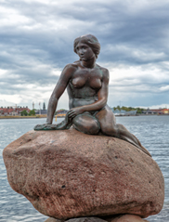

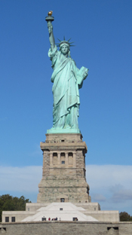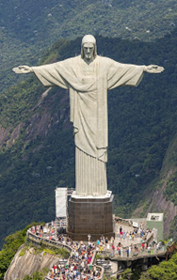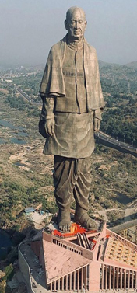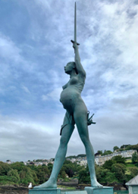

1. Shipped over in 214 crates in 1885, who gave the Statue of Liberty to the USA?
2. Name this statue in Ilfracombe by Damien Hirst

1. Based on a 1837 fairy tale by which Danish author

1. Name this statue in Rio De Janeiro
2. What is the name of the world’s tallest statue standing 597 feet high and located in Gujarat India

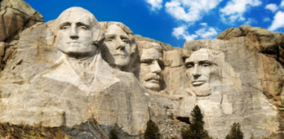Round 5. Sculptures and statues

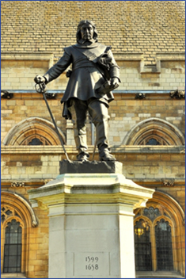

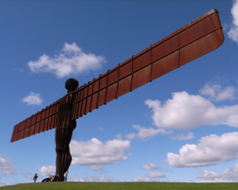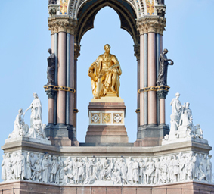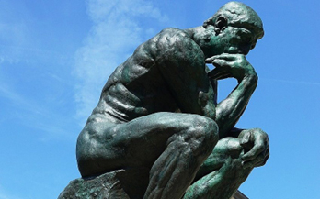

1. Standing outside the house of commons who is this
2. This memorial golden statue was made for which prince
3. Name the sculptor
4. “The Thinker” a statue by Auguste Rodin can be found in which city?
5. Name the four US   
   presidents in this sculpture

Round 6. Colours

|  |  |  |  |  |
| --- | --- | --- | --- | --- |
| 1 |  |  | 6 |  |
| 2 |  |  | 7 |  |
| 3 |  |  | 8 |  |
| 4 |  |  | 9 |  |
| 5 |  |  | 10 |  |

1. THERE IS ONLY ONE **GREEN** PARTY M.P. – WHICH CITY IS REPRESENTED?
2. THE COLOUR **CHERRY** IS ASSOCIATED WITH WHICH RUSSIAN PLAYWRIGHT 1860 -1904?
3. WHO HAD A HIT WITH “THE LADY IN **RED** “ A SONG APPARENTLY WRITTEN BECAUSE MEN CANNOT REMEMBER WHAT THEIR WIVES WERE WEARING WHEN THEY FIRST MET?
4. DEEP **BLUE** BECAME THE FIRST MACHINE TO DEFEAT WHICH REIGNING WORLD CHAMPION CHESS PLAYER IN 1997?
5. FOUNDED IN 1994, IT’S SERVICE WAS DISCONTINUED IN 2019 - WHAT DID THE COMPANY **ORANGE** SUPPLY?
6. CHARLIE **BROWN** IS THE MAIN CHARACTER OF WHICH COMIC STRIP?
7. WHO WROTE THE BEST-SELLING EROTIC ROMANCE NOVEL ”FIFTY SHADES OF **GREY**” ?
8. **BLACK** HAWK DOWN IS A 2001 WAR FILM ABOUT THE U.S. MILITARY'S 1993 RAID IN WHICH CITY?
9. WHO HAD A **PINK** RANGE ROVER REPOSSESSED IN 2019 IN A BANKRUPTCY BATTLE?
10. ESPECIALLY AT CHRISTMAS, WHERE WOULD YOU FIND 'THE **PURPLE** ONE'?

Round 7. Sport in 2023

|  |  |  |  |  |
| --- | --- | --- | --- | --- |
| 1 |  |  | 6 |  |
| 2 |  |  | 7 |  |
| 3 |  |  | 8 |  |
| 4 |  |  | 9 |  |
| 5 |  |  | 10 |  |

1. 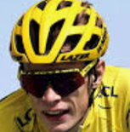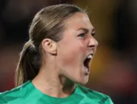WHO SAVED A PENALTY IN THE WOMEN’S   
     
   FOOTBALL CUP FINAL – NAME THIS   
     
   ENGLISH GOALKEEPER?
2. WHAT NATIONALITY WAS THE WINNER OF THE TOUR DE FRANCE?
3. WHERE WAS THE BRITISH OPEN GOLF CHAMPIONSHIP HELD?
4. 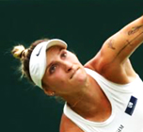NAME THE LADIES WIMBLEDON TENNIS CHAMPION?
5. WHO WON THE F.A. CUP FINAL?
6. NAME THE RACE CIRCUIT WHERE THE ABU DHABI   
     
   F.1. G.P WAS HELD LAST MONTH?
7. WHAT IS THE NAME OF THE FAMOUS ITALIAN JOCKEY WHO RETIRED AGED 52?
8. WHAT WAS THE RESULT OF THE 4TH TEST MATCH OF THE ASHES?
9. THE WINNING NATION OF THE FINAL OF THE RUGBY WORLD CUP WAS?
10. IN WHICH COUNTRY WERE THE WORLD ATHLETIC CHAMPIONSHIPS HELD?

Round 8. Name these bones

|  |  |  |  |  |
| --- | --- | --- | --- | --- |
| 1 |  |  | 6 |  |
| 2 |  |  | 7 |  |
| 3 |  |  | 8 |  |
| 4 |  |  | 9 |  |
| 5 |  |  | 10 |  |

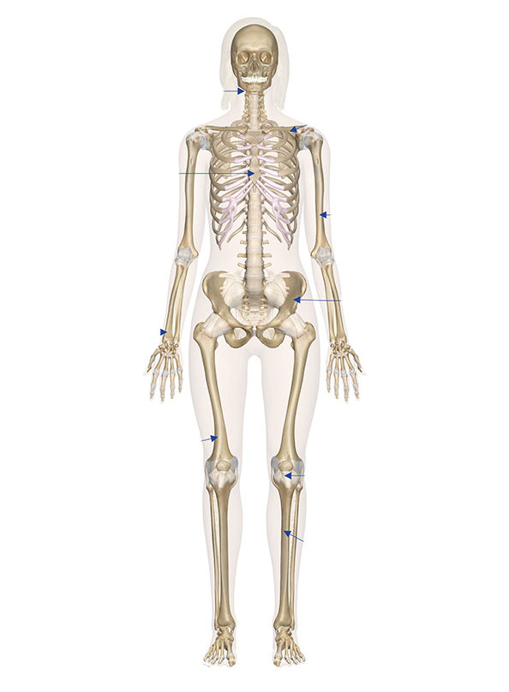

1

2

3

4

7

8

5

9

6

10

Round 9. Write the presenter’s letter in the box under their relevant show

**E**

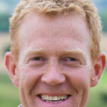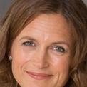

**B**

**A**

**C**

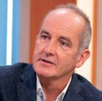

E

**D**

**G**

**F**



**I**

**J**

H